Name: __________________________ Per ______ 8th Grade Social Studies
Date: ____________________ Miss Meister

Unit #7: World War II
Weekly #1

This assignment is due on: _______________________________

Part 1: Multiple Choice – Circle your answer and write it on the line (1 point)

_____ 1. President FDR’s 1940 Lend Lease Program was created to

(1) Established the United Nations
(2) Provide war materials to allied powers
(3) Expand New Deal programs to help sharecroppers
(4) Relocate Japanese Americas.

“Yesterday, December 7, 1941 – A day which will live in infamy” –President FDR
_____ 2. President Roosevelt used these words to describe the

(1) D-day invasion of Normandy
(2) Dropping of the atomic bomb on Hiroshima
(3) Surprised attack on Pearl Harbor
(4) Start of World War II in Europe.

“Blitzkrieg sweeps across Europe”
“Japanese Americans Relocated”
“Truman takes over as President”
_____ 3. To which 20th- century period do these headlines refer?

(1) Persian Gulf War
(2) World War I
(3) Vietnam War
(4) World War II

_____ 4. Great Britain and France followed a policy of appeasement when they

(1) Opposed United States effort to rearm
(2) Signed the agreements at the Yalta Conference
(3) Rejected an alliance with the Soviet Union
(4) Allowing Germany to expand its territory.

_____ 5. In Europe during the 1930’s, economic instability to the

(1) Rise of fascist dictatorships
(2) Development of nuclear arms
(3) Abandonment of colonial territory
(4) Establishment of the League of Nations

Part 2: Short Answer questions
1. Who are the fascist dictators who came to power during the Great Depression?

2. What area did Hitler gain through the policy of Appeasement?

3. What event lead to the immediate outbreak of World War II?

4. Once the war broke out, how did the American government and the citizens respond?

5. What event brought America into World War II?

Part 3: Matching

1. Executive Order 9066
______ Passed to provide weapons to the Allies if they had cash to pay for them.

_____ mandated that Japanese and Japanese Americans relocated into Internment camps away from the Pacific coast.

_____ Great Britain and France agreed to give Hitler Sutenland in exchange for Peace.

______ All of the dictators felt this document was unfair to their countries.

_____ Event that brought America into World War II.

2. Cash & Carry

3. Policy of Appeasement

4. Treaty of Versailles

5. Pearl Harbor

Part 4: DBQ Document
Directions: Answer the following questions below in full sentences by restating and answering the question.

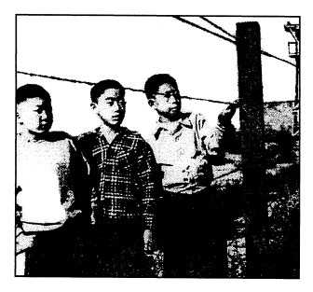
1. What is historical context of Executive Order 9066?

_______________________________________________________________________________________

2. Who authorized Executive Order 9066?

_______________________________________________________________________________________

3. What was the purpose of Executive Order 9066?

_______________________________________________________________________________________

_______________________________________________________________________________________

_______________________________________________________________________________________

_______________________________________________________________________________________

