Name: __________________________ Per ______ 8th Grade Social Studies
Date: ____________________ Miss Meister
/23
Unit #7: World War II
Weekly #2

This assignment is due on: _______________________________

Part 1: Fill in the Blank

Rosie the Riveter | Manhattan Project | Executive Order 9066
Yalta Conference | Pearl Harbor

1. America entered World War II due to the Japanese attack at ____________________________.

2. ___________________________ was used as propaganda to encourage women to work in factories.

3. President Roosevelt’s __________________________________, placed Japanese Americans into internment camps because they were seen as a threat to national security.

4. It was the top secret _______________________________ that was responsible for developing an atomic bomb in America.

5. Churchill, Roosevelt and Stalin all met at the __________________________________, to discuss post war plan and aid to Europe.

Part 2: True/False Statements: Identify if the answer is true or false by circling the correct answer. If the answer is FALSE CORRECT THE STATEMENT TO MAKE IT TRUE.

1. A worldwide Great Depression, led to the rise of Democratic dictators such as; Hitler and Mussolini. (True or False)

2. America’s “Lend Lease Act” and “Cash and Carry” provided aid to the Allied powers. (True or False)

3. The policy of Appeasement permitted Great Britain to gain control of Sutenland, a German speaking section of Czechoslovakia. (True or False)

4. Japanese immigrants/Americans were removed from the east coast due to their classification of being a threat to national security during World War II. (True or False)

5. President FDR stated, “A day which will live in infamy”, in response to the attack on Pearl Harbor (True or False)

Part 3: Multiple Choice

_____ 1. What was a primary goal of Franklin D. Roosevelt, Winston Churchill, and Joseph Stalin when they met at the Yalta Conference in 1945?
(1) discussing strategies to regain control of France from German control.
(2) setting up postwar reorganization of Europe.
(3) protecting the colonial empires of the warring nations
(4) sharing the development of atomic weapons

Based on the photograph below, answer questions 2 and 3 using your knowledge of Social Studies.
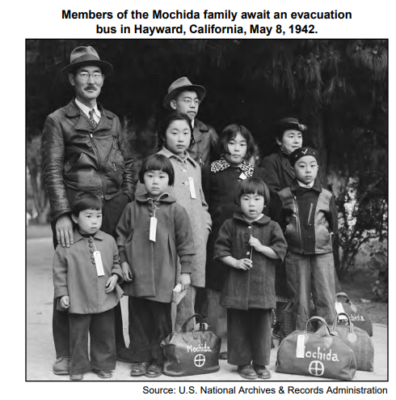
_____ 2. This photograph taken during World War II shows the
(1) deportation of Japanese Americans to Japan
(2) arrival of new Japanese immigrants in California
(3) migration of Japanese American families to the East Coast
(4) relocation of Japanese Americans to internment camps

_____ 3. The situation shown in this photograph was most directly the result of
(1) legislation in California
(2) a presidential executive order during World War II
(3) a Supreme Court decision
(4) a constitutional amendment

_____ 4. What was one way United States participation in World War II affected the American economy?
(1) Many factories were forced out of business.
(2) Military supplies were produced instead of some consumer goods.
(3) Imports of products from Europe significantly increased.
(4) Shortages caused by the war contributed to the start of the Great Depression

_____ 5. During World War II, the Manhattan Project was the name of the plan to
(1) open a second front in Europe
(2) capture Pacific islands held by the Japanese
(3) develop the atomic bomb
(4) liberate German concentration camps

Part 4: DBQ Document
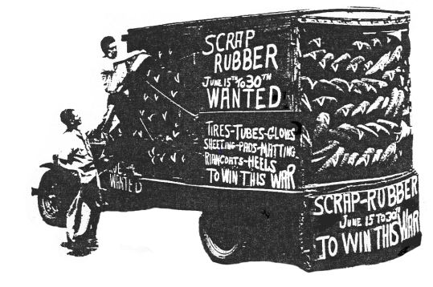
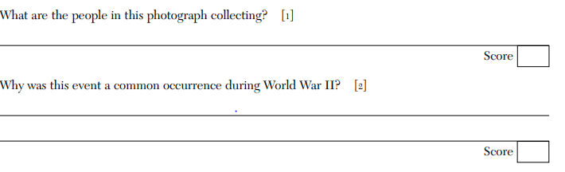

– Place the following events in chronological order below on the timeline.
Part 5: Timeline

Japanese Attack on Pearl Harbor | America declares Neutrality | U.S declares war on Japan | Lend Lease Act | Germany invades Poland

